**Data Encryption Demonstration**

The first step in encrypting data is to create an encryption key. This key will serve as the secret ingredient, allowing us to transform readable data into an encrypted format and later decrypt it back to its original form. Keep this key secure, as anyone who has it can decrypt your data.

**Generate the Encryption Key**

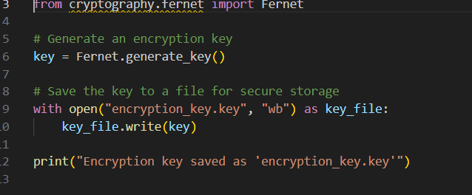

**Encrypting the File**

With the encryption key in hand, we can now encrypt a file. For this example, we’ll use a file called `sample.txt` that contains sensitive information. The code below will read the contents of `sample.txt`, encrypt it, and save the encrypted version as `sample_encrypted.txt`.

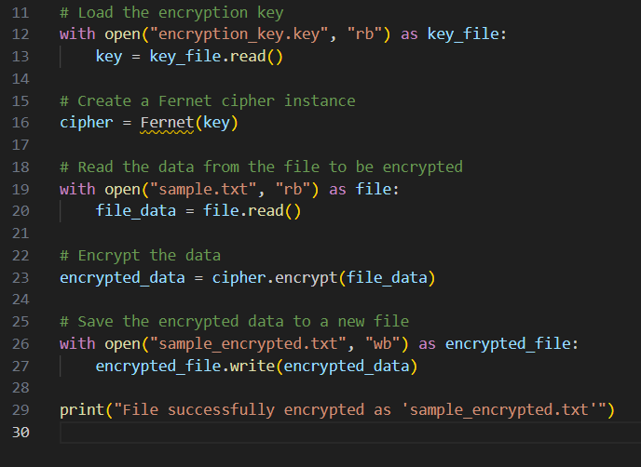

**Decrypting the Encrypted File**

Now, let’s decrypt `sample_encrypted.txt` back to its original form using the same encryption key. The decrypted data will be saved as `sample_decrypted.txt`.

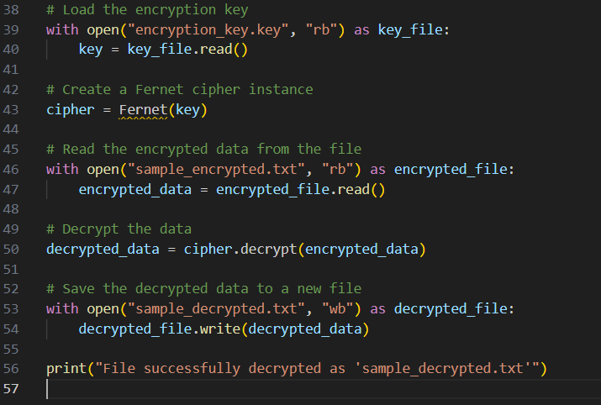

**--------------------------------------------------------------------------------------------------------------------------------------------------------**

**The Importance of Encryption in Data Security**

Encryption is a foundational component of cybersecurity. It provides a layer of protection for sensitive data, ensuring that it remains secure whether it’s being stored (data at rest) or transmitted (data in transit). Below, we’ll explore how encryption plays a vital role in these two contexts.

**1. Protecting Data in Transit**

Data in transit refers to information being sent over networks, whether public, private, or wireless. This includes emails, messages, or any data moving between devices or networks. When data is in transit, it’s vulnerable to interception, eavesdropping, and man-in-the-middle attacks, where attackers position themselves between the sender and receiver.

**How Encryption Secures Data in Transit:**

**Confidentiality**: Encryption transforms data into an unreadable format, ensuring that only authorized users with the correct decryption key can access the original content.

**Integrity** : Encryption protects data from tampering. If an attacker tries to alter the encrypted data, the decryption will fail, signaling that the data has been compromised.

**Authentication**: Encryption often includes mechanisms to verify the sender’s authenticity, making it possible to confirm that the data originates from a trusted source.

**Real-World Example**: HTTPS, the secure version of HTTP, uses encryption to protect data in transit over the internet. When a user accesses a website via HTTPS, their connection is encrypted with SSL/TLS, protecting login details, payment information, and other sensitive data from interception by malicious parties.

**2. Securing Data at Rest**

Data at rest is information stored on a physical medium, such as a hard drive, SSD, or cloud storage. Even though it’s not actively moving across networks, data at rest remains vulnerable to unauthorized access, especially in cases of physical theft or unauthorized access to storage devices.

**Why Encrypt Data at Rest:**

**Confidentiality**: By encrypting stored data, it remains unreadable without the decryption key, thus keeping it secure even if a storage device is stolen or accessed by an unauthorized individual.

**Data Breach Prevention**: Encryption is essential for compliance with regulations and standards, as it reduces the risk of data breaches. In the event of hardware theft or loss, encryption ensures that the data on the device is inaccessible to unauthorized parties.

**Real-World Example**: Many organizations encrypt hard drives and sensitive files on laptops and mobile devices. This is especially important in fields like healthcare and finance, where personal data is highly sensitive and legally protected.

**--------------------------------------------------------------------------------------------------------------------------------------------------------**

**Security Best Practices for Encryption**

When implementing encryption, keep the following best practices in mind:

1. **Use Strong Encryption Standards**: Always use established encryption algorithms, such as AES (Advanced Encryption Standard), RSA, or ECC (Elliptic Curve Cryptography). Avoid outdated algorithms like DES or MD5, which are vulnerable to attacks.

2. **Protect the Encryption Key**: The security of encrypted data depends on the encryption key. Store keys in a secure location, use key management solutions, and never hard-code keys directly into source code.

3. **Regularly Update and Rotate Keys**: Changing encryption keys periodically reduces the risk of key compromise. If a key is exposed, it should be replaced immediately, and all encrypted data should be re-encrypted with the new key.

4. **Utilize Encryption in Multiple Layers**: Layer encryption to protect data in both transit and at rest, even within internal systems, to ensure comprehensive security.

5. **Follow Compliance Requirements**: Various industries, such as finance and healthcare, have strict requirements for data encryption. Adhering to these regulations (e.g., GDPR, HIPAA) is crucial for avoiding legal issues and fines.